**Niger country profile**

Published

19 February 2018

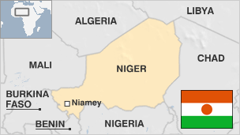

**A vast, arid state on the edge of the Sahara desert, Niger is rated by the UN as one of the world's least-developed nations.**

Niger fell victim to a series of coups and political instability following its independence from France in 1960.

Today the country struggles in the face of frequent droughts, insurgency and wide-spread poverty. Niger is betting on increased oil exploration and gold mining to help modernize its economy.

But basic rights issues, such as slavery - which was only banned in 2003 and still remains a problem - and a high rate of illiteracy and disease, remain stubborn challenges.

The US has a significant military presence in the country, intended to combat Islamist militants. Niger has become noted as a major transit route for migrants heading to Europe.

* See [more country profiles](http://news.bbc.co.uk/1/hi/country_profiles/) - Profiles compiled by [BBC Monitoring](http://www.bbc.co.uk/monitoring)

**Niger leader: Mahamadou Issoufou**

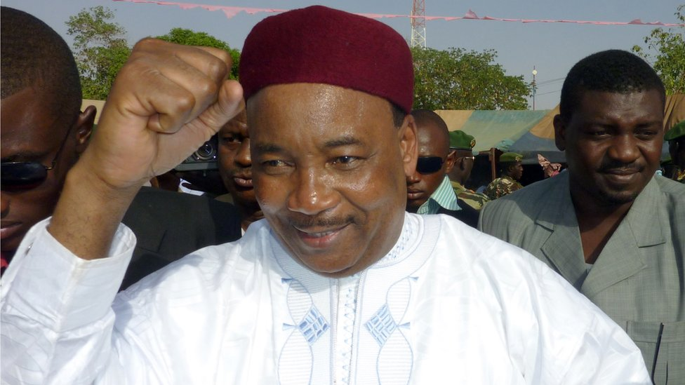image copyrightGetty Images

Veteran opposition leader Mahamadou Issoufou became president in March 2011 polls that ended a year-long military junta.

The election was aimed at returning democracy after former president Mamadou Tandja was ousted by the army in February 2010 following a decade in power.

The military junta that overthrew him vowed to usher in a civilian government, and none of its members ran in the election.

Mr Issoufou gained another term in a run-off election in March 2016 that was boycotted by supporters of his opponent, Hama Amadou, who had been jailed.

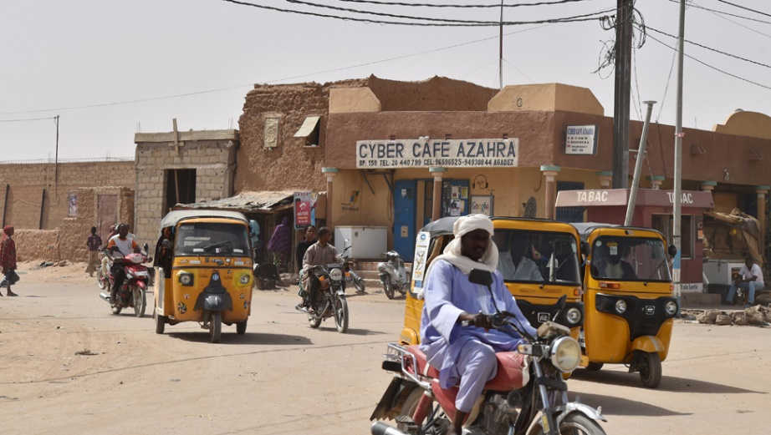image copyrightGetty Images

Radio is a key news source and local privately-owned stations operate alongside the national state broadcaster.

Many media outlets struggle to survive financially. Journalists face difficulties, including detention or prosecution over critical reporting.

Around 10% of citizens are online.

# Niger timeline

Published

19 February 2018

## A chronology of key events:

**1890** - French occupy Niger.

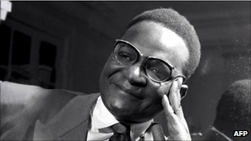image copyrightAFP

image captionPresident Hamani Diori led Niger for 14 years after independence before being overthrown in a coup

**1958** - Niger becomes autonomous republic of the French Community.

**1960** - Niger becomes independent; parliament elects Hamani Diori president.

**1968-73** - Severe drought devastates Niger's livestock and crop production.

**1974** - Hamani Diori overthrown in military coup led by Lt-Col Seyni Kountche.

**1987** - Ali Seybou, the armed forces chief of staff, succeeds Kountche who dies of a brain tumour.

**1989** - A new constitution brings Niger back to civilian rule, but under a one-party system; Seybou re-elected president.

## Ban on parties lifted

**1990** - Seybou legalizes opposition parties following a wave of strikes and demonstrations.

**1990** - Rebellion by Tuareg people in the north begins.

**1991** July - Constitutional conference strips Seybou of his powers and sets up a transitional government under Andre Salifou.

**1992** - New constitution allowing multiparty elections ratified.

**1993** - Mahamane Ousmane elected president and his coalition, the Alliance of the Forces of Change wins a majority of seats in parliament.

**1995** - Ceasefire between the government and the Tuareg's Revolutionary Armed Forces of the Sahara comes into effect.

## More coups

**1996** January - Ousmane ousted in a coup led by Col Ibrahim Mainassara, who bans all political parties.

**1996** May - New constitution giving the president increased powers approved in a referendum; ban on political parties lifted.

**1996** July - Mainassara wins presidential election.

**1997** - The Democratic Renewal Front, a hard-line Tuareg group, signs peace accord with government.

**1999** April - Major Daouda Wanke assumes power following the assassination of Mainassara by his bodyguards.

**1999** August - New constitution reversing the increase in the presidency's powers approved in a referendum.

**1999** October and November - Mamadou Tandja elected president and his party, the National Movement for the Society in Development, wins majority of seats in parliament.

**2001** January - Niger bans hunting in an effort to save its wildlife population, which includes the lion, the giraffe and the hippopotamus.

**2002** August - Soldiers mutiny in the east and in the capital and demand the payment of wage arrears and better conditions. The rebellions are put down.

## Uranium claim

**2003** January - US President George W Bush claims Iraq tried to acquire uranium from Niger for its nuclear programme. The claim also made in UK's September 2002 dossier on Iraq.

**2003** March - Nuclear watchdog tells UN that documents relating to Iraq-Niger uranium claim are forged, concludes specific allegations are unfounded.

**2004** July - First-ever local elections. Parties backing the president win most of the seats.

**2004** December - President Mamadou Tandja wins a second term in office with 65.5% of the vote in a second-round ballot.

**2005** July - International Court of Justice awards Niger most of the river islands along its disputed border with Benin.

## Tuareg rebellion

**2007** August - Government declares alert in the north, giving the army greater powers to fight Tuareg rebels who have staged deadly attacks over the past six months.

**2008** June - Police arrest former Prime Minister Hama Amadou on charges of embezzling state funds.

**2009** April - Government and Tuareg rebels of the Movement of Niger People for Justice (MNJ) agree to end hostilities after talks in Libyan capital Tripoli.

**2009** May-June - President Mamadou Tandja suspends constitution and assumes emergency powers after Constitutional Court rules against his plans for a referendum on whether to allow him to seek a third term.

**2009** August - Much-criticized referendum endorses new constitution which allows President Tandja to rule for three more years and gives him broader powers.

**2009** October - Opposition boycotts election to replace parliament that President Tandja dissolved to stop it blocking his constitutional changes. Mr Tandja's supporters win overwhelming victory over independent candidates.

**Coup**

**2010** February - President Tandja is ousted in a coup and a senior army officer, Col Salou Djibo, named head of a military government. The African Union suspends Niger's membership.

**2010** March - Coup leader Col Salou Djibo promises to return Niger to democracy, but sets no date for elections.

Military junta appoints a transitional government headed by a civilian prime minister, Mahamadou Danda.

**2010** May - Food shortages affecting 7 million people, aid agencies say.

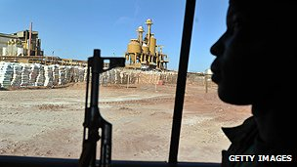image copyrightGetty Images

image captionThe French-owned uranium mine near Arlit, where several foreigners were kidnapped

**2010** October - New constitution designed to restore civilian rule approved in referendum.

**Return to civilian rule**

**2011** March - Mahamadou Issoufou wins presidential elections and is sworn in the following month.

**2011** May - Former President Mamadou Tandja, who was ousted in the 2009 coup, is released from prison after charges of misappropriating public funds are dropped.

**2011** July - Five soldiers arrested for allegedly plotting to assassinate President Issoufou and take power in a coup.

**2012** February - Thousands cross into Niger to escape fighting in Mali.

**2013** May - Suicide bombers stage separate attacks on a military barracks and a French-run uranium mining site in the north. The government blames al-Qaeda-linked militants.

**2013** June - Historical city of Agadez awarded World Heritage status by UNESCO.

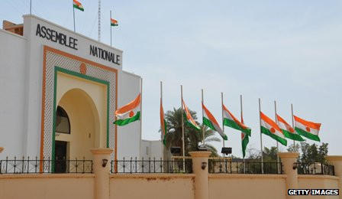image copyrightGetty Images

image captionFlags fly at half-mast to during three days of mourning for 92 migrants who perished while trying to make a desert crossing

**2014** May - Niger and French nuclear energy group Areva agree a new deal for mining uranium, involving an increase in royalties, which critics had said were too low.

Man sentenced following the first ever conviction for slavery in Niger.

**2014** May - A man is sentenced to four years in jail in the first ever conviction for slavery in the country.

**2015** February - Niger agrees to contribute to a regional force to fight Boko Haram militants.

**2015** November - Opposition leader Hama Amadou is arrested on his return to the country, year after fleeing to avoid child-trafficking charges. He is later approved as a candidate the forthcoming presidential polls.

**2016** March - Mahamadou Issoufou is re-elected in a run-off election boycotted by supporters of his opponent, Hama Amadou.

**2016** June - Boko Haram militants attack the southeastern town of Bosso, killing 30 soldiers.

**2016** September - The US confirms that it is building a military base in the central city of Agadez capable of deploying drones against militants.

**2017** March - State of emergency declared in western areas bordering Mali following attacks blamed on militants linked to the Movement for Oneness and Jihad in West Africa.

A court sentences exiled opposition leader Hama Amadou to a year in prison for child smuggling. He was not in court and denied the charges, describing them as politically motivated.

**2017** April - The military says it has killed 57 members of Boko Haram who attacked a military position near Gueskerou, in the south-east.

**2017** July - Five West African countries, including Niger, launch a new regional force to confront Islamic militants in the Sahel region.

**2017** October - Three US commandos on a joint patrol with local troops are killed in an ambush near Tongo Tongo.

**2018** January - Italy's parliament approves the deployment of up to 470 troops in Niger to combat migration and the trafficking of people towards Europe.